Cybersecurity Incident Report

Scenario
Review the following scenario.
You work as a security analyst for a travel agency that advertises sales and promotions on the company’s website. The employees of the company regularly access the company’s sales webpage to search for vacation packages their customers might like.
One afternoon, you receive an automated alert from your monitoring system indicating a problem with the web server. You attempt to visit the company’s website, but you receive a connection timeout error message in your browser.
You use a packet sniffer to capture data packets in transit to and from the web server. You notice a large number of TCP SYN requests coming from an unfamiliar IP address. The web server appears to be overwhelmed by the volume of incoming traffic and is losing its ability to respond to the abnormally large number of SYN requests. You suspect the server is under attack by a malicious actor.
You take the server offline temporarily so that the machine can recover and return to a normal operating status. You also configure the company’s firewall to block the IP address that was sending the abnormal number of SYN requests. You know that your IP blocking solution won’t last long, as an attacker can spoof other IP addresses to get around this block. You need to alert your manager about this problem quickly and discuss the next steps to stop this attacker and prevent this problem from happening again. You will need to be prepared to tell your boss about the type of attack you discovered and how it was affecting the web server and employees.

Wireshark Log results
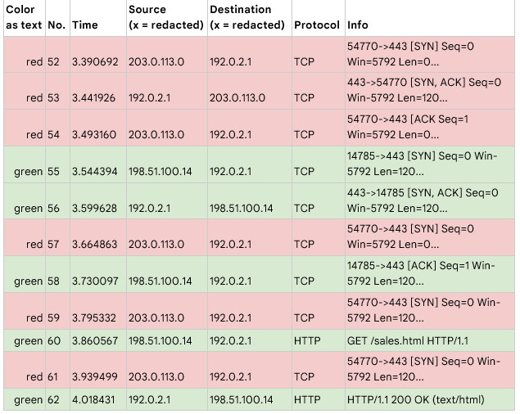
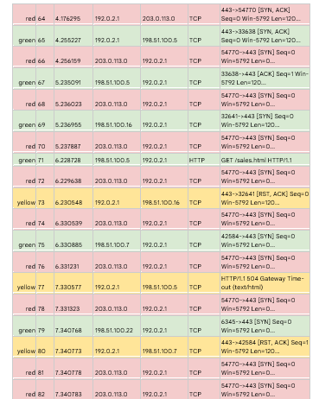

Section 1: Identify the type of attack that may have caused this
network interruption
One potential explanation for the website's connection timeout error message is the possibility of a SYN Flood Attack. This is a type of Denial-of-Service (DoS attack) where attackers simulate a TCP connection by flooding a server with large number of SYN packets/requests.

The logs show that an overwhelming amount of SYN requests were sent by an unknown IP address and as time went on legitimate users were receiving timeout error messages when they tried to access the website and the server eventually stopped responding.

Section 2: Explain how the attack is causing the website to malfunction
When website visitors try to establish a connection with the web server, the TCP protocol establishes a three-way handshake:
- The Source IP address send a SYN(Synchronize) packet to the Destination to connect.
- The Destination which is the web server send back a SYN, ACK (Synchronize, Acknowledged) to acknowledge the request and agree to the connection.
- Then the source sends back an ACK acknowledging the permission to connect.
The HTTP protocol will then be to successfully establish the connection to the webserver.

In this Instance, an attacker has flooded the website with an unbearable amount of SYN packets all at once, which exceeds the bandwidth of the server. The Server is now overwhelmed and cannot establish connection to the site.

The logs indicate that the web server has become overwhelmed and is unable to process the visitors’ SYN requests. The server is unable to open a new connection to new visitors who receive a connection timeout

